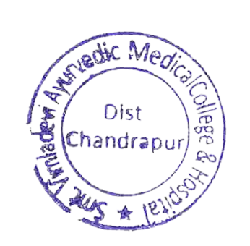
Link of Google Classroom

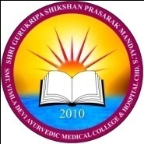 | SGSPM’s  SMT. VIMLADEVI AYURVEDIC MEDICAL COLLEGE & HOSPITAL WANDHARI, CHANDRAPUR

Sr. | Department | Links
 | Samhita siddhanta | https://classroom.google.com/c/NTIyNTIwNTAxOTg5?cjc=ozlp5km
 | Rachanasharir | https://classroom.google.com/c/NjExMzg0MDcxMTI3?cjc=cx255qm
 | Kriyasharir | https://classroom.google.com/c/NjExMTU4MzQzNDY5?cjc=7ncrs67
 | Prasutitantra evam streeroga | https://classroom.google.com/c/MTE1MjU2OTg5NDgw?cjc=hubu7qm
 | Agadtanta | https://classroom.google.com/c/NjA4ODMzNDg2NTg4?cjc=acs5qci
 | Kaumarbhritya | https://classroom.google.com/c/NjExNjIxNTQ1NzE2?cjc=p5htp5g
 | Swasthavritta | https://classroom.google.com/c/NjExNjM1MDI2NTE2?cjc=nvuakkq
 | Kayachikitsa | https://classroom.google.com/c/NjExMTI2Njc3OTIy?cjc=t6iivff
 | Shalakyatantra | https://classroom.google.com/c/NjExNjIzODY1NDY1?cjc=mi2ffqr
 | Shalyatantra | https://classroom.google.com/c/NjExNjI5NDk5MDUz?cjc=4g4u6p2
 | Library | https://classroom.google.com/c/NTIyNjQ5MzA1Mjk1?cjc=p5hz6mg

